Practical Task Assessment
Student 20231244

Cisco Packet Tracer Device Configuration

Contents
1. Company Name and Device Naming Scheme 3
1. Configure the router and switch hostnames according to your chosen naming scheme but DO NOT change the topology names. (4 marks) 9
2. Only Switch 1 should be a VTP server, record your configuration choices. (6 marks) 9
3. Create and name VLAN 2 and VLAN 3 using food items that you love, and record these in your word document 9
4. Create VLAN 4 named Star & Create VLAN 99 named Mgmt to use as the management and native VLAN. 9
All trunk connections should be set to always trunk -VLAN 4 traffic should not be allowed on any trunks. (8 marks) 11
5. All non-trunk ports must always be access ports -For security purposes, all unused access ports must be administratively shut down and assigned to the Star VLAN. ( vlan 4 is Star) 14
6. Switch Fa0/1 ports must be assigned to VLAN 2 and Fa0/2 ports to VLAN 3. 14
7. Active access ports should dynamically learn MAC addresses and store them in the running configuration for a maximum of only one MAC address; any violations should increment the violation counter in addition to filtering the offending traffic. 15
8. All VLANs currently have the same root switch. For load balancing, identify the current root switch and change the root switch for VLAN 2, but allow the original switch to become root if the new root switch fails. Document which switch was the original rot switch and which is the new root switch. 15
9. Ensure all devices in the Hamilton LAN can communicate with each other and IP address assignment is fully documented. Pinging PCs from Router! 16
10. EIGRP is the routing protocol to be used at both sites. A static route to the Raglan 192.168.4.0/24 network is required as a backup route in case EIGRP fails. 17
11. A static default route for traffic to the ISP is required. 17
EIGRP should be configured using your day of birth as the AS number. Record the AS number in your word document. Auto-summarization should not be used. Do not use the classful address. Ensure that Router1 can swap routes with the Raglan router (Router2). If configuration changes are required at the Raglan site, make the changes and record them in your document. 18
Verify full connectivity in Hamilton – e.g. PC1 can successfully ping all other PCs in Hamilton, each switch management address, each active Router1 interface, and the ISP. Correct any issues before proceeding. 18

1. Company Name and Device Naming Scheme
Company Name: Polaris IT
Device | Name | Interface | IP Address/Mask | Gateway
Router1 | PolarisRT1 | Gi 0/1 | 10.44.0.1/25 | -----
Switch1 | PolarisSW1 | VLAN 1 | 10.44.0.2/25 | 10.44.0.1
PC1A | PolarisPC1A | Fa 0/0 | 10.44.0.2/25 | 10.44.0.1
PC2A | PolarisPC2A | Fa 0/0 | 10.44.0.3/25 | 10.44.0.1
PC3A | PolarisPC3A | Fa 0/0 | 10.44.0.4/25 | 10.44.0.1
PC1B | PolarisPC1B | Fa 0/0 | 10.44.2.2/25 | 10.44.2.1
PC2B | PolarisPC2B | Fa 0/0 | 10.44.2.3/25 | 10.44.2.1
PC3B | PolarisPC3B | Fa 0/0 | 10.44.2.4/25 | 10.44.2.1
Device Naming Scheme(Hamilton site):

2. IP Network ID: 10.44.0.0/16
Month of Birth: August
Day of Birth: 29th
Network ID: 10.44.0.0/16
1. 400 Hosts in VLAN 2
- IP Address: 10.44.0.0/23
- Network Address: 10.44.0.0
- Usable Host IP Range: 10.44.0.1 - 10.44.1.254
- Broadcast Address: 10.44.1.255
- Total Number of Hosts: 512
- Number of Usable Hosts: 510
- Subnet Mask: 255.255.254.0
2. 180 Hosts in VLAN 3
- IP Address: 10.44.2.0/24
- Network Address: 10.44.2.0
- Usable Host IP Range: 10.44.2.1 - 10.44.2.254
- Broadcast Address: 10.44.2.255
- Total Number of Hosts: 256
- Number of Usable Hosts: 254
- Subnet Mask: 255.255.255.0
3. 12 Hosts in VLAN 99
- IP Address: 10.44.3.0/28
- Network Address: 10.44.3.0
- Usable Host IP Range: 10.44.3.1 - 10.44.3.14
- Broadcast Address: 10.44.3.15
- Total Number of Hosts: 16
- Number of Usable Hosts: 14
- Subnet Mask: 255.255.255.240
Summary of Subnetting:
- VLAN 2: Uses a /23 subnet to accommodate 400 hosts.
- VLAN 3: Uses a /24 subnet to accommodate 180 hosts.
- VLAN 99: Uses a /28 subnet to accommodate 12 hosts.
This configuration is designed to conserve address space while providing enough IP addresses for each VLAN based on your requirements.

Steps for Configuration
1. Configure the Router:
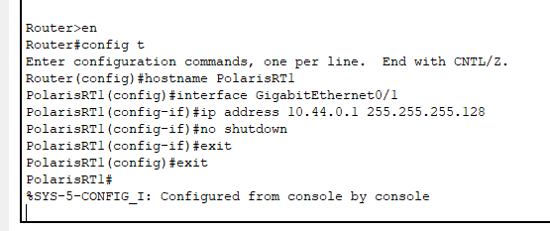

2. Configure the Switch:{screenshots for just Switch 1}

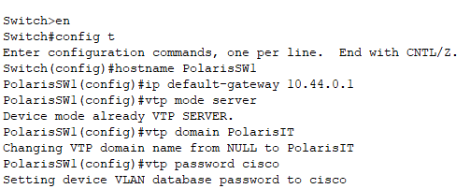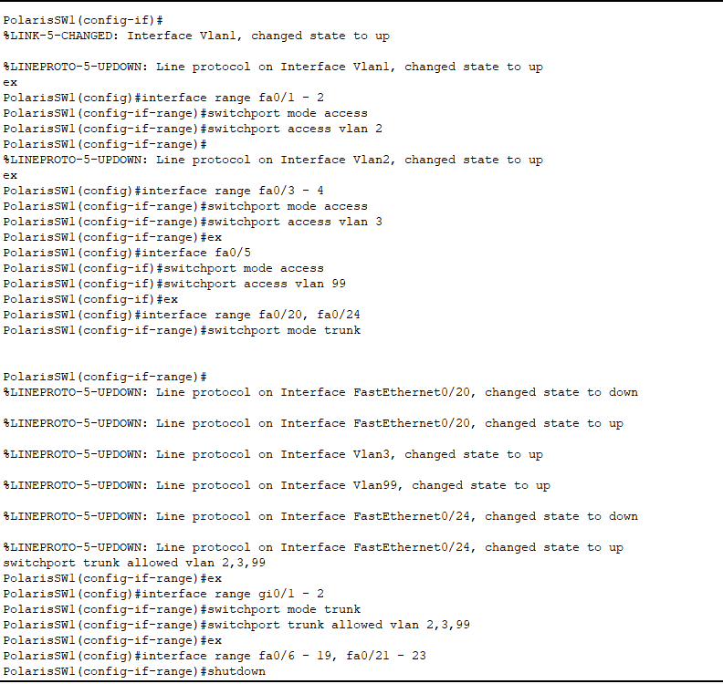
3. Configure PCs:
For PolarisPC1A:
- IP Address: 10.44.0.2
- Subnet Mask: 255.255.255.128
- Gateway: 10.44.0.1
For PolarisPC2A:
- IP Address: 10.44.0.3
- Subnet Mask: 255.255.255.128
- Gateway: 10.44.0.1
For PolarisPC3A:
- IP Address: 10.44.0.4
- Subnet Mask: 255.255.255.128
- Gateway: 10.44.0.1
For PolarisPC1B:
- IP Address: 10.44.2.2
- Subnet Mask: 255.255.255.128
- Gateway: 10.44.2.1
For PolarisPC2B:
- IP Address: 10.44.2.3
- Subnet Mask: 255.255.255.128
- Gateway: 10.44.2.1
For PolarisPC3B:
- IP Address: 10.44.2.4
- Subnet Mask: 255.255.255.128
- Gateway: 10.44.2.1
4. Verification
After setting up the configurations, use the ping command on each device to ensure connectivity:
ping 10.44.0.2
ping 10.44.0.3
ping 10.44.0.4
ping 10.44.2.2
ping 10.44.2.3
ping 10.44.2.4

To subnet a network to support 400 hosts, 180 hosts, and 12 hosts in different VLANs while conserving address space, we'll calculate the required subnets as follows:
Requirements:
- VLAN 2: 400 hosts
- VLAN 3: 180 hosts
- VLAN 99: 12 hosts
We'll be using the 10.44.0.0/16 network.
Subnet Calculation:
- VLAN 2: 400 hosts
  - We need at least 400 IP addresses.
  - The closest power of 2 that supports 400 hosts is 512 (which requires 9 bits for hosts).
  - Subnet Mask: /23 (255.255.254.0)
- VLAN 3: 180 hosts
  - We need at least 180 IP addresses.
  - The closest power of 2 that supports 180 hosts is 256 (which requires 8 bits for hosts).
  - Subnet Mask: /24 (255.255.255.0)
- VLAN 99: 12 hosts
  - We need at least 12 IP addresses.
  - The closest power of 2 that supports 12 hosts is 16 (which requires 4 bits for hosts).
  - Subnet Mask: /28 (255.255.255.240)
Subnet Allocation:
VLAN 2 Subnet:
- Subnet ID: 10.44.0.0/23
- Subnet Mask: 255.255.254.0
- First Usable Address: 10.44.0.1
- Last Usable Address: 10.44.1.254
- Broadcast Address: 10.44.1.255
VLAN 3 Subnet:
- Subnet ID: 10.44.2.0/24
- Subnet Mask: 255.255.255.0
- First Usable Address: 10.44.2.1
- Last Usable Address: 10.44.2.254
- Broadcast Address: 10.44.2.255
VLAN 99 Subnet:
- Subnet ID: 10.44.3.0/28
- Subnet Mask: 255.255.255.240
- First Usable Address: 10.44.3.1
- Last Usable Address: 10.44.3.14
- Broadcast Address: 10.44.3.15
Summary Table:
VLAN | Subnet ID | Subnet Mask | First Usable Address | Last Usable Address | Broadcast Address
VLAN 2 | 10.44.0.0/23 | 255.255.254.0 | 10.44.0.1 | 10.44.1.254 | 10.44.1.255
VLAN 3 | 10.44.2.0/24 | 255.255.255.0 | 10.44.2.1 | 10.44.2.254 | 10.44.2.255
VLAN 99 | 10.44.3.0/28 | 255.255.255.240 | 10.44.3.1 | 10.44.3.14 | 10.44.3.15
These subnets allow you to efficiently use your IP address space while meeting the needs of each VLAN.

Configure the router and switch hostnames according to your chosen naming scheme but DO NOT change the topology names. (4 marks)

Only Switch 1 should be a VTP server, record your configuration choices. (6 marks)


Create and name VLAN 2 and VLAN 3 using food items that you love, and record these in your word document

Create VLAN 4 named Star & Create VLAN 99 named Mgmt to use as the management and native VLAN.

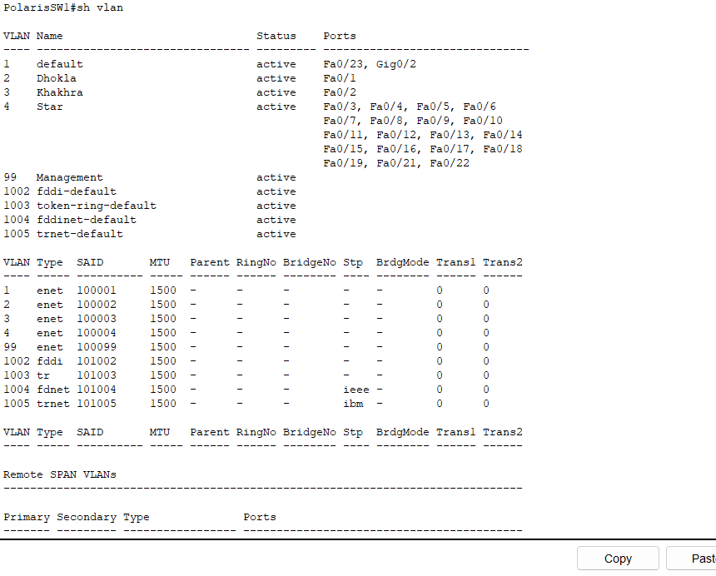

All trunk connections should be set to always trunk
-VLAN 4 traffic should not be allowed on any trunks. (8 mark) 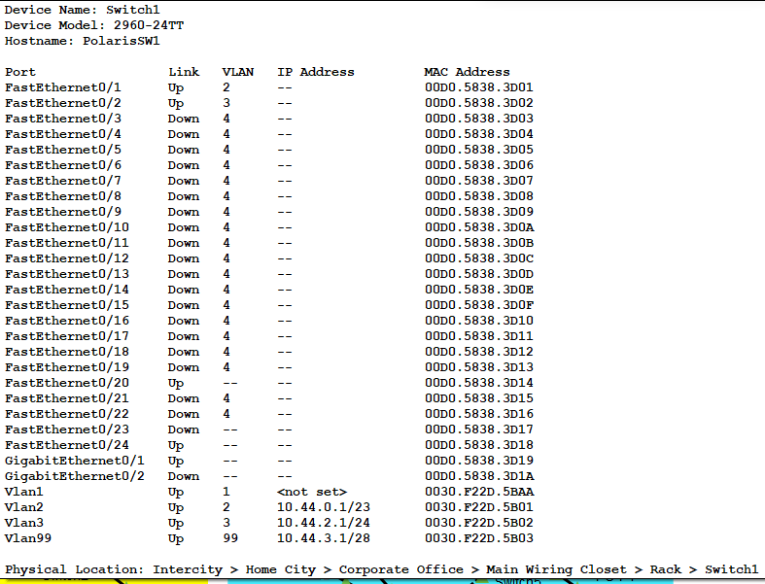

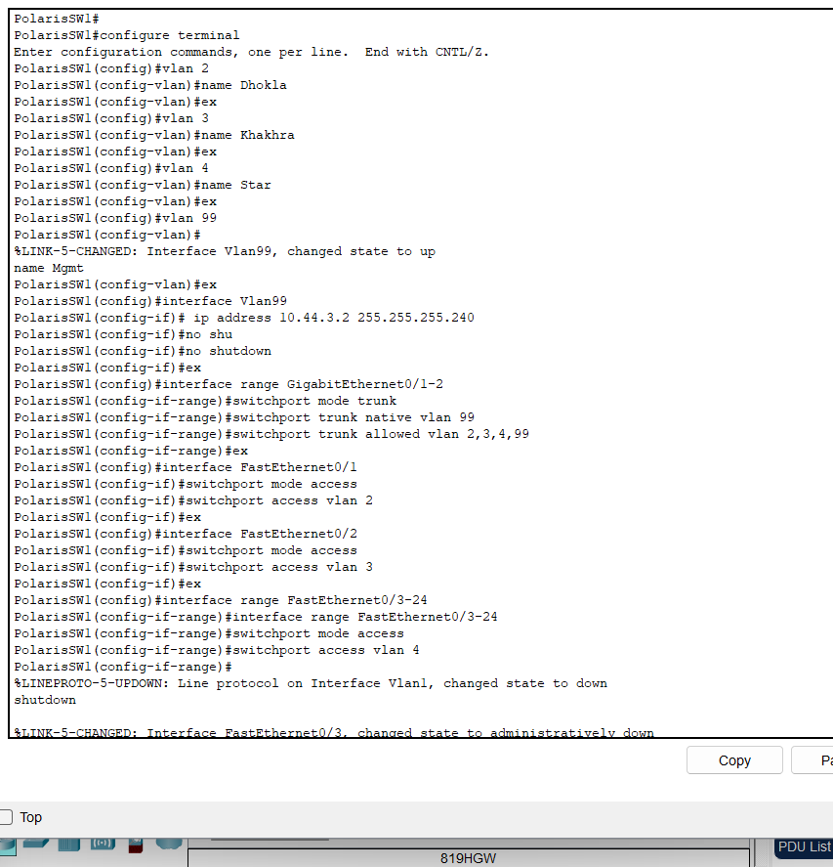

All non-trunk ports must always be access ports
-For security purposes, all unused access ports must be administratively shut down and assigned to the Star VLAN. ( vlan 4 is Star)


Switch Fa0/1 ports must be assigned to VLAN 2 and Fa0/2 ports to VLAN 3.

Active access ports should dynamically learn MAC addresses and store them in the running configuration for a maximum of only one MAC address; any violations should increment the violation counter in addition to filtering the offending traffic.
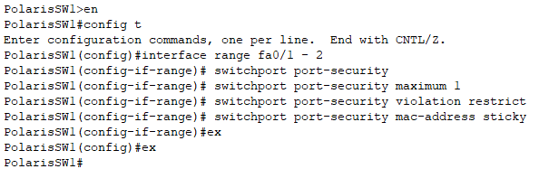

All VLANs currently have the same root switch. For load balancing, identify the current root switch and change the root switch for VLAN 2, but allow the original switch to become root if the new root switch fails. Document which switch was the original root switch and which is the new root switch.
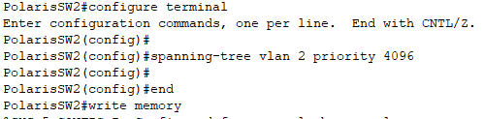
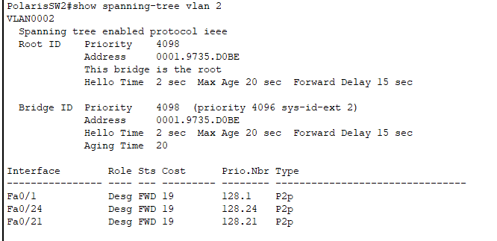

Ensure all devices in the Hamilton LAN can communicate with each other and IP address assignment is fully documented. Pinging PCs from Router!
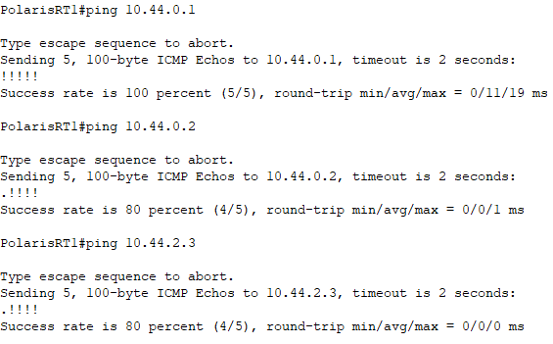

EIGRP is the routing protocol to be used at both sites. A static route to the Raglan 192.168.4.0/24 network is required as a backup route in case EIGRP fails.
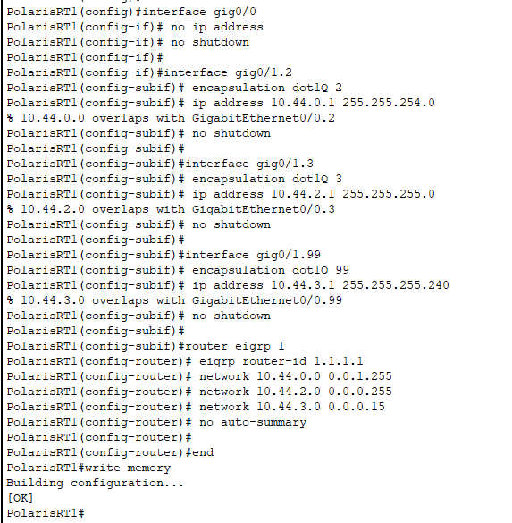

A static default route for traffic to the ISP is required.

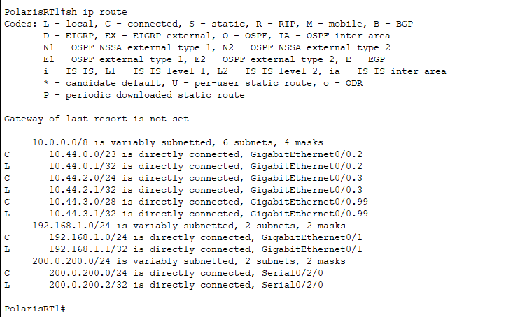

EIGRP should be configured using your day of birth as the AS number. Record the AS number in your word document. Auto-summarization should not be used. Do not use the classful address. Ensure that Router1 can swap routes with the Raglan router (Router2). If configuration changes are required at the Raglan site, make the changes and record them in your document.

Verify full connectivity in Hamilton – e.g. PC1 can successfully ping all other PCs in Hamilton, each switch management address, each active Router1 interface, and the ISP. Correct any issues before proceeding.

Raglan Site Troubleshooting
Address and document the following issues in Raglan:
- Users in VLAN3 on switch 4 can communicate with each other but report they cannot
communicate with VLAN3 users on switch 5.
- RPC2D is the only user on Switch 6 that can communicate with other users. (3 marks)
- RPC4B on Switch 5 can’t communicate with any other device on the network. (1 mark)

